Station 16
8130 3rd Street
Wellington, CO 80549

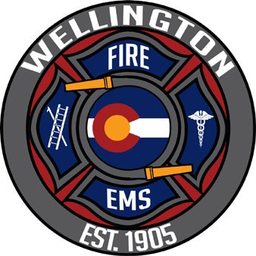
Wellington Fire Protection District
REGULAR MEETING MINUTES
Station 17
108 E County Road 66 Fort Collins, CO 80524

The Regular Board Meeting of the Wellington Fire Protection District was called to order at approximately 4:05 PM. The meeting was held at Station 16 located at 8130 3rd St, Wellington, CO 80549 on February 9th, 2022. Please contact our administrative office for social distancing guidelines or additional attendance accommodations.

Pledge of Allegiance
Roll Call DIRECTORS PRESENT – STORY, REED, PIERSON, SARNO, PETTIT
Additions/Deletions to the Agenda
Conflicts of Interest None
Correspondence None
Public Comment

Linda Knaack, 4214 White Deer Ln, announced she is a candidate for the board of directors’ election.

Consent Agenda
- Regular Board Meeting Minutes for January 12, 2022
- Paid Bills and Reference Check Register
- Year-to-Date Budget Pulled to agenda Item 1
- Balance sheet Pulled to agenda Item 1

M/S STORY/SARNO to APPROVE the Regular Board Meeting Minutes for January 12. Voice votes unanimous; motion PASSED.
Chief’s Report
- Working on FF eligibility list, we have 3 vacancies currently
- FPPA Audit is roster is complete, the Board and Chief Patterson have access to the District FPPA account
- Looking to realign payroll to bi-weekly
- Transitioning from paper check to bill.com
- Creating email for positions/alias instead of a person

District Business
- Year-to-Date Budget & Balance Sheet pulled from Consent Agenda
Sara Simmons with JVG reviewed the new financial reporting format for the Board of Directors.
M/S PETTIT/SARNON to APPROVE the Year-to-Date Budget & Balance Sheet. Voice votes unanimous; motion PASSED.

- Election update discussion

Ashley Macdonald notified the board of directors that enough self-nomination forms have been submitted to validate the District will not be cancelling the election this year. The meet and greet was received well and appreciated by the community. The calendar of events was briefly reviewed.
- Grant update discussion

Ashley Macdonald applied for and received $20,400 on behalf of WFPD in grant funds from the Larimer County Immediate Needs Grant. The grant funds can be used through March of 2024. To date we have requested for reimbursement of 536.25 hours for the month January. This funding will help keep our budget for critical response from being impacted by unanticipated expenses from COVID

- Fire Chief Selection process

Director Reed notified the Board the first step is to form a Chief Selection Committee. Director Reed suggested the Board conduct an internal hiring process for fire chief process.
M/S REED/STORY to form a fire chief selection committee comprised of the board of directors. Voice votes unanimous; motion PASSED.
DIRECTOR REED issued an apology to the operations staff that they were not invited to be a part of the selection committee. She felt it would create an uncomfortable situation. The board would like to invite them to join during the interview portion of the process.

- Feb 23. Work Session agenda discussion

A draft of upcoming meeting agendas was provided for the board to review and use as a tool for tracking future agenda item. There was general discussion about potential topics and time needed to address future items.

M/S REED/PIERSON for the February 23 Work Session to start at 4:00 pm and will be held at Station 16

Guests or Presentations
  - 2021 Year End Call Volume Presentation Deleted

Chief Patterson conducted the Firefighter Badge Oath of Office & Pinning Ceremony for:
    - FF. Radford
    - FF. Souceck
    - FF. Clausen
Other – none

M/S PETTIT/REED to ADJOURN at 5:25 PM. Voice votes unanimous; motion PASSED, and meeting is ADJOURNED.

P.O. BOX 10, Wellington, CO 80549 | (970) 568-3232 | www.WFPD.org

